**7. Part-of-Speech (POS) Tagging with NLTK**

**Aim:**  
To perform POS tagging using the NLTK library.

**Algorithm:**

1. Import the nltk library.
2. Tokenize the input text into words.
3. Apply nltk.pos_tag() to get POS tags.

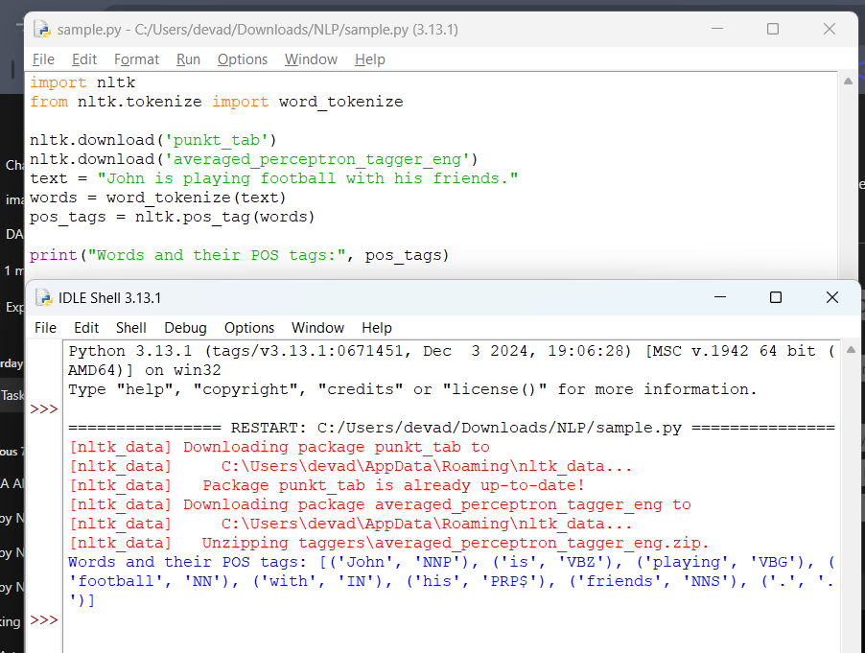

**Result:**  
POS tagging is performed successfully.